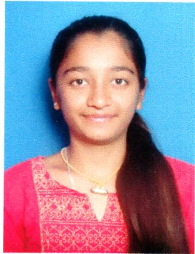

* *Successfully achieved the certification of* ***Google Cloud Certified Digital Cloud Leader.***

***CERTIFICATION***

***Title: “Designing of Wireless Sensor Node For providing good Quality***

***drinking to Public “***

***Description:*** *The main aim of this project is to designing an intelligent water quality monitoring setup implemented in IOT Platform. This will help in maintaining the quality of water with the help of sensor and application.*

**Tools**

* MS Word, MS Excel.

**Databases**

* MySQL, ANSI SQL.

**Programming Languages**

* C, Java, SpringBoot.

**Web Technologies**

* HTML, JavaScript, CSS.

**IDE**

* Eclipse and VS Code.
* KANNADA
* ENGLISH
* Good Communication.
* Delegation.
* Teamwork.
* Adaptability.
* Cooperation.
* Creativity.

***LANGUAGES***

***HOBBIES***

***SKILL HIGHLIGHTS***

***ACADEMIC PROJECT***

* ***Bachelor of Engineering in Computer Science and Engineering***

*Government Engineering College, Ramanagaram.*

*August 2021.*

* ***Diploma in Computer Science and Engineering***

*Government Polytechnic Arakere, Srirangapattana.*

*July 2018.*

***SUMMARY***

***Programmer Analyst***

*TRV Bond Construction-CIO-CDS*

*Sept 2022 – June 2023*

* *Learnt how to work using Spring Boot.*
* *Worked on Basic of Angular.*

`

Full Stack Developer with 1.9 years of hands-on experience designing, developing, and implementing applications and solutions using a range of technologies and Programming Languages. Seeking to leverage broad development experience and hands-on technical expertise in a challenging role as a full stack developer.

***EDUCATION***

***EXPERIENCE***

***Nishanka H P***

***TECHNICAL SKILLS***

* Playing Carrom
* Playing Badminton
* Cooking

nishankahp314@gmail.com

Do No 112, Haniyambadi, Mandya Taluk, Mandya District, Karnataka - 571403

+91 9844462359